Group: C1.036

Sevillano Barea, Alejandro - alesevbar@alum.us.es Naredo Bernardos, Ignacio- ignnarber@alum.us.es

Robles Borrego, Adrián - adrrobbor@alum.us.es

Sabido González, Francisco Manuel - fransabgon@alum.us.es

Escudero Aldana, David - davescald@alum.us.es

Content Table

1. Executive Summary 2

2. Revision Table 3

3. Introduction 3

4. Contents 3

4.1 Planning Chapter 3

4.2 Progress Chapter 3

5. Conclusions 6

6. Bibliography 6

**1. Executive Summary**

This report documents the project's status, including planning and progress. It describes the tasks performed, the resources used, and the development progress. Additionally, it presents performance metrics and a comparison between planning and actual execution.

**2. Revision Table**

|  |  |  |
| --- | --- | --- |
| Revision number | Date | Description |
| 1 | 02/03/2025 | The report was created |
| 2 | 13/03/2025 | Report completed |

**3. Introduction**

This document presents the Planning and Progress Report for the project, specifically prepared for Student 4. It provides a comprehensive record of the project's planning and development so far, detailing the tasks completed, their role within the project, and the individuals responsible for them. Additionally, it compares the estimated and actual time spent on each task.

The report also outlines the methodologies used for task management, ensuring adherence to best practices in execution and documentation. It highlights the main challenges encountered during development and the solutions applied to address them.

Moreover, it includes an initial cost estimation based on allocated work hours and available resources, followed by an analysis comparing estimated and actual costs. Performance indicators are also incorporated to assess efficiency and goal completion, offering a clear perspective on the project's current status and potential areas for improvement in future phases.

**4. Contents**

**4.1** **Planning Chapter**Task List

|  |  |  |  |  |
| --- | --- | --- | --- | --- |
| Task | Description | Responsible person | Planned time | Real time |
| 3 | Implement the assistance agents entity, storing their employee code, spoken languages, associated airline, start date, and optionally, their bio, salary, and profile picture. | Francisco Manuel Sabido González | 40 minutes | 35 minutes |
| 4 | Develop the claims entity, recording details such as the registration date, passenger email, description, type of issue, and acceptance status. | Francisco Manuel Sabido González | 40 minutes | 30 minutes |
| 5 | Implement a tracking log system to document each step in the claim resolution process, including the last update date, current step, resolution percentage, and final resolution details. | Francisco Manuel Sabido González | 40 minutes | 20 minutes |
| 6 | Create test data to validate the application, including predefined assistance agent accounts and an additional agent account with no associated data. | Francisco Manuel Sabido González | 40 minutes | 80 minutes |
| 7 | Provide a link to your planning dashboard in GitHub to review the tasks, their current status, and your schedule. | Francisco Manuel Sabido González | 5 minutes | 5 minutes |
| 15 | Develop a dashboard with key performance indicators, such as claim resolution and rejection rates, the top three months with the most claims, and statistical data on logs and claims handled. | Francisco Manuel Sabido González | 30 minutes | 15 minutes |
| 16 | Produce a UML domain model regarding the information requirements in your project. | Francisco Manuel Sabido González | 45 minutes | 30 minutes |
| 26 | Integrate a web service to retrieve and store flight status and delay information, ensuring the selected API is free of charge to avoid additional costs. | Francisco Manuel Sabido González | 60 minutes | No completed |
| 27 | Produce an analysis report. | Francisco Manuel Sabido González | 20 minutes | 17 minutes |
| 28 | Produce a planning and progress report. | Francisco Manuel Sabido González | 20 minutes | 28 minutes |

Screenshots of Progress

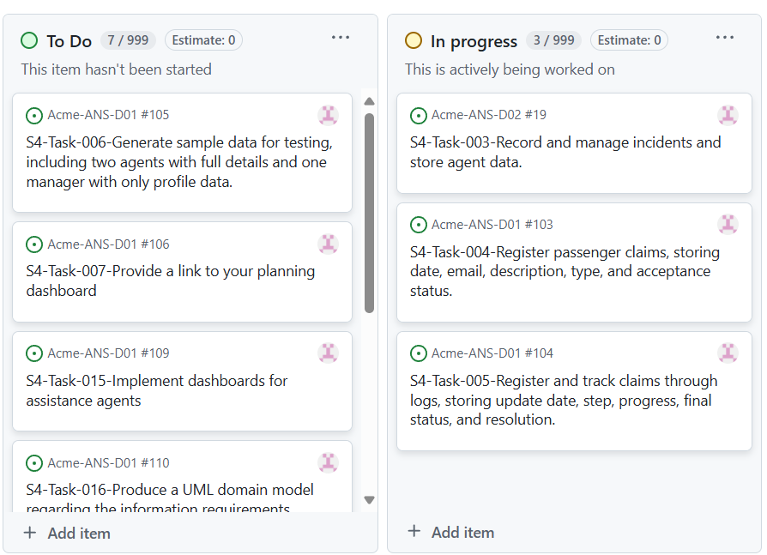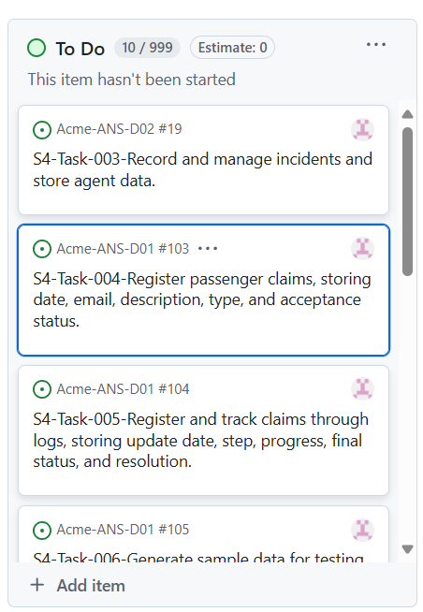

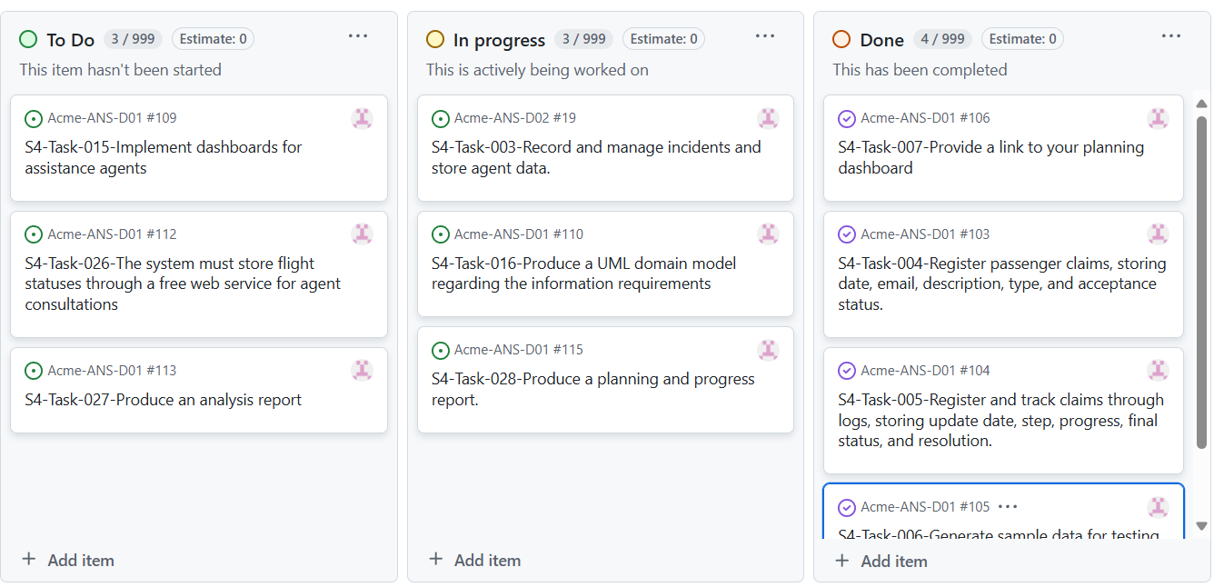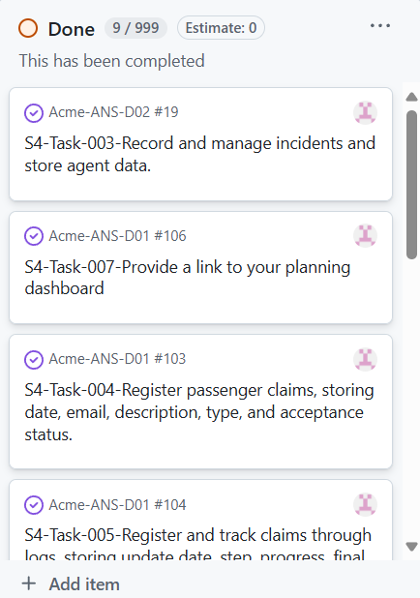

In the first image (top left), all tasks remain pending and have yet to be started.  
In the second image (top right), we can observe that some tasks have already been started.  
In the third image (bottom left), we can see tasks that are already completed, others in progress, and some still pending.  
In the fourth image (bottom right), all tasks have already been completed.

Budget Estimation

|  |  |  |  |
| --- | --- | --- | --- |
| Role | Estimated hours | Hourly cost | Total cost |
| Developer | Approximately 6 hours | 20,00€ | 120,00€ |

**4.2** **Progress Chapter**  
Challenges and Resolutions

|  |  |  |
| --- | --- | --- |
| Problem | Description | Solution |
| Intentionally blank |  |  |

Cost Comparison

|  |  |  |  |  |
| --- | --- | --- | --- | --- |
| Role | Estimated hours | Real hours | Hourly cost | Real cost |
| Analist | Approximately 6 hours | Approximately 5 hours | 20,00€ | 100,00€ |

**5. Conclusions**

This report provides a detailed analysis of the project's status, covering both planning and progress. It documents the tasks performed, resources used, and performance metrics, enabling a comparison between the initial plan and actual execution.

The results reflect efficient time and resource management, with several tasks completed within the estimated time and some optimizations in execution. However, the integration of the web service for retrieving flight status remains pending, highlighting the need for better management of external dependencies in future phases.

The budget analysis shows that actual costs remained within the expected margin, demonstrating good financial control throughout development. Additionally, the use of management methodologies ensured a structured and well-documented execution of the project.

In conclusion, the project has progressed satisfactorily, meeting its objectives and providing a clear overview of the remaining challenges. It is recommended to continue optimizing time management in critical tasks and ensure the completion of pending components to maintain efficiency and development quality.

**6. Bibliography**

Does not apply